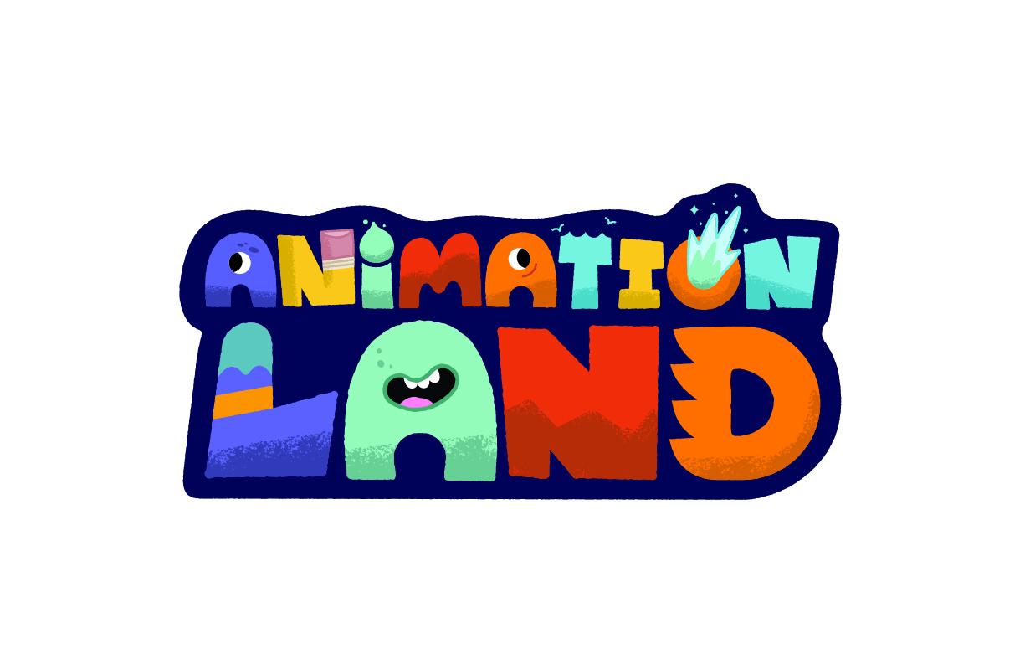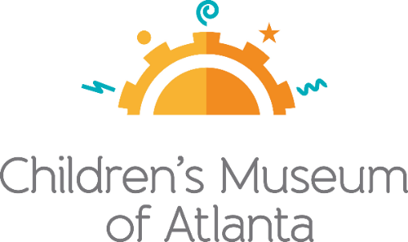

FOR MORE INFORMATION
Sarah Wynn Benton
BRAVE Public Relations
404.233.3993
sbenton@emailbrave.com
FOR IMMEDIATE RELEASE

Children’s Museum of Atlanta’s Newest Feature Exhibit “Animationland” Breaks Down the Art and Science of Animation, Launching May 18
Kids join Tracey the pencil dog and her crew as they explore the basic steps of
turning a story into an animated work

ATLANTA (April 24, 2024) – Animationland, Children’s Museum of Atlanta’s newest featured exhibit, will educate little creatives on the art and science of animation while transporting guests of all ages to a fantastical land with a quirky cast of characters including Rooth, Drop, Inky, Uno and Kari. The exhibit focuses on the framework of the animation process using interactive features, including a sketching studio, a sound effects booth and the opportunity to plan and star in a stop-motion production. Families can visit the Museum to experience Animationland starting Saturday, May 18 until Sunday, Sept. 8. Animationland is sponsored locally by Publix Supermarket Charities with additional support from City of Atlanta Mayor's Office of Cultural Affairs and Fulton County Arts & Culture.

Animationland immerses families in the creative process and makes animating approachable and fun," said Executive Director Edwin Link. "Animation is a captivating blend of art, math and science, so while kids will be delighted to see their creations come to life, parents will love that the exhibit gets their gears turning. In a movie town like Atlanta, it's especially exciting to get families playing with the moving image."

The vibrant, whimsical exhibit allows kids and adults to get lost in the creative process, even if they have never thought of themselves as artists. The exhibit features Tracey’s Studio where little ones act as animators using a storyboard to develop their own narrative. Guests will place storyboard cards together to curate an animation and watch it come to life on the screen! Blub-Glub Village’s underwater world gives kids a chance to enjoy an iconic full-body experience as they create 14-frame animations.

The Prickle Desert features a multitude of learning opportunities, including different frame rates, movement concepts and more, and guests can test out the mutoscope showing a reel of images like a flip book animation. Little animators can also gather props at Comfort Peaks to aid in creating their own animation. Here they will immerse themselves into a cozy world of smiling mountains, wacky space creatures and Rooth the lumbering mountain. The Foley booth challenges the Museum’s small animators to add sounds to short animated clips using ordinary objects and props.

Inspiration is everywhere at Animationland. Developed and produced by the Oregon Museum of Science and Industry (OMSI), Animationland will offer a fully immersive, interactive exhibit where guests learn to incorporate animation skills into the creation process. This enables guests to understand the interplay that occurs between art and science and how they can apply those skills to tell their own stories in unique and dynamic ways. In order to create a fully immersive environment, OMSI collaborated with expert creative studio Jolby & Friends to develop original characters, illustrations and animation.
###

About OMSI:
Founded in 1944, the Oregon Museum of Science and Industry (OMSI) is one of the nation’s leading science museums, a worldclass tourist attraction, and an award-winning educational resource for the kid in each of us. OMSI operates the largest museum-based outdoor science education program in the country and provides traveling and community outreach programs that bring science learning opportunities to schools and community organizations in nearly every county in Oregon. OMSI is located at 1945 SE Water Avenue, Portland, OR 97214. For general information, call 503.797.4000 or visit omsi.edu. Connect with the museum on Facebook, Twitter, and Instagram.

About Children’s Museum of Atlanta:
Children’s Museum of Atlanta is the only educational venue of its kind in Atlanta, presenting educational programs and exhibits designed for young children ages 0-8. The mission of Children's Museum of Atlanta is to change the world by sparking every child's imagination, sense of discovery and learning through the power of play. With learning zones consisting of bright, creative and hands-on exhibits, the Museum supports inventive play-based exploration and experiential learning focused on the whole child. Core competencies for literacy, math and science are promoted throughout all exhibits and programming in alignment with the state and national Core Performance Standards. Children’s Museum of Atlanta also offers memberships. For more information or to support Children's Museum of Atlanta, visit childrensmuseumatlanta.org or call 404.659.KIDS [5437].

Museum Admission: Purchasing tickets online is recommended. Phone booking is available with ample notice and will be booked via online reservation. Members are encouraged to pre-book and will be able to redeem their $5 voucher online. Babies 11 months and younger and members are admitted. All daily programs are included in price of admission. For more information regarding ticket and membership options, visit childrensmuseumatlanta.org

Museum Hours: The Museum will operate in a timed entry model where guests can visit between the hours of 10 a.m. and 3:30 p.m. on Monday, Tuesday, Thursday and Friday and 9:30 a.m. - 4:30 p.m. on Saturday and Sunday. The Museum will be closed on Wednesdays. Please check the Museum website to confirm hours of operation.

